**SHT20 Temperature Humidity Sensor Module With RS485 Modbus High Precision Temperature Humidity Monitor Transmitter Sensor Probe DC4-30V**

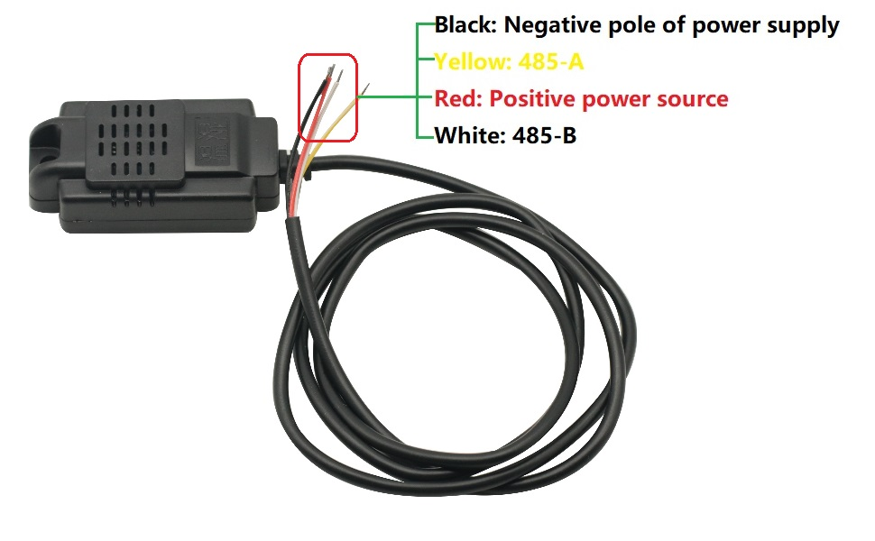

The product adopts industrial-grade chip, high-precisionSHT20The temperature and humidity sensors, excellent reliability, high precision and interchangeability of the product.usingRS485Hardware interface(With lightning protection design), the protocol layer is compatible with industry standardModbus Rtu -The agreement.This product setMODBUSAgreement with ordinary at an organic whole, the user can choose communication protocols, common agreement with automatic upload function (The connectionRS485Through a serial port is automatically output mode tool temperature and humidity).

Product highlights:

Industrial products, high progressSHT20The temperature and humidity sensors,RS485Communication;

standardMODBUSAgreement with ordinary at an organic whole, the user can choose communication protocol;

Baud rate can decide for themselves;

General agreement with automatic upload function, upload speed can decide for themselves.

Product parameters:

Working voltage:DC4-30 v(the highest do not exceed33 v)

The most powerful:0.2 W.

Working temperature:The temperature- 20℃+ 60℃Humidity,0% RH to 100% RH

Accuracy:The temperature+ / - 0.3℃(25℃)Humidity,(25 + / - 3% RH℃)

Output interface:RS485Communication (standardMODBUSProtocol and custom ordinary), as shown in the agreement

Device address:Can be set up1-247.By default,1

Baud rate:The default9600(the user can set),8Bits of data,1A stop, without checking

Size:60 * 30 * 18

**MODBUS Agreement**

